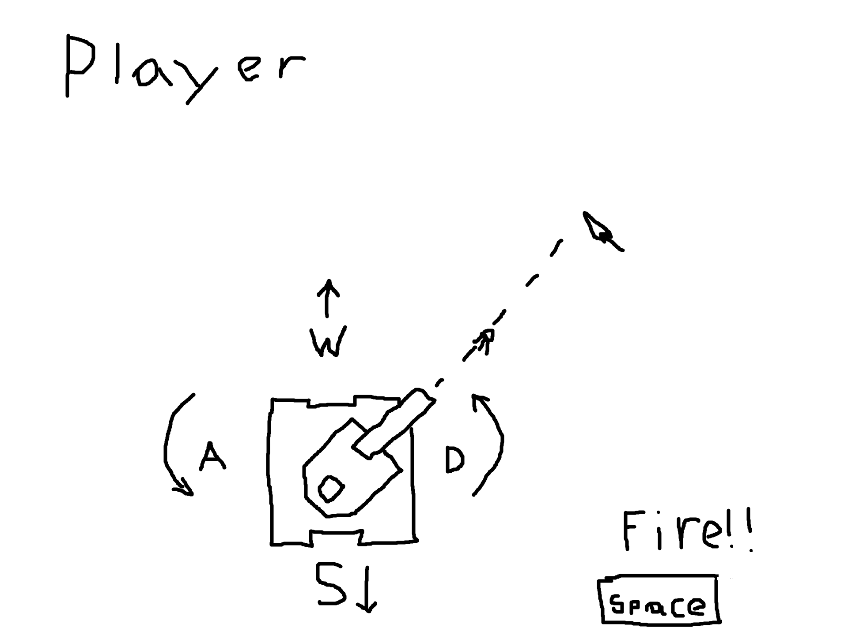

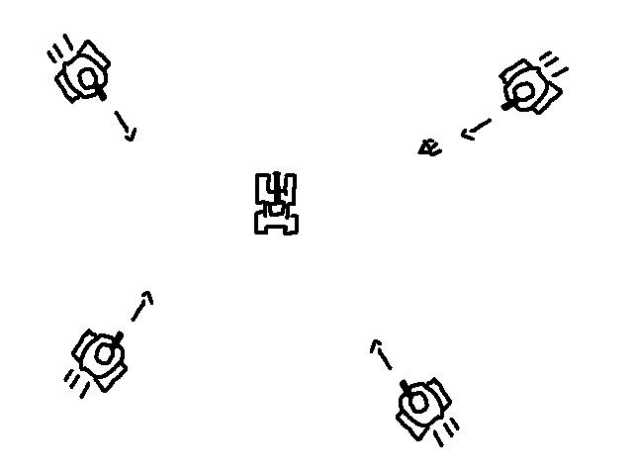

Sprites

* Player Tank
  + Player Tank Base
    - Moves with WASD
    - Uses rotation upon using A and D
    - If hit by an enemy bullet, then damage will be taken
    - Game will use a health and Shield system, much like Spaceship 2
    - Is born on spawn, where indicated in the diagram, and doesn’t die until the game ends
  + Player Tank Cannon
    - Will follow Player Tank Base
    - The cannon will aim at the mouse
* Enemy Tank
  + Enemy Tank Base
    - Moves forward a random amount of time, and will occasionally rotate, if it hits a cover, or the player, it will rotate again until it can move
    - Will use only health, but will be somewhat durable
    - If it dies, it will duplicate
    - It will spawn in a random location
  + Enemy Tank Cannon
    - Will move with the Enemy Tank Base, and will always be pointed toward the Player’s position.
    - Will fire at the player randomly
    - Will duplicate with the base tank
* Covers
  + Will act as cover from all enemies and bullets
  + If a bullet hits it, it will despawn
  + If a tank is moving into it, it will stop the tank from moving
  + Basically, its a wall
* Bullets
  + Will be hiding offscreen until needed
  + If it hits either the player or enemy (depending on who fired the bullet) it will reduce health or shield
    - Shield if its the player, and the player’s shields are still charged
    - Health if its the enemy, or if the player’s shields aren’t charged
* Crosshair
  + Will move to where the mouse is located
  + It’s only there for player convenience, to help the player aim their cannon
* Powerups
  + Shield Batteries
    - If touched by the player, the player’s shields will recover by 15.
    - It will then reset to a random location
    - If its touching the covers, it will reset to a random location

Scoring

* Starting
  + The game will start when the player hits START from the menu screen, or if they hit RESET from the ending screen
* Ending
  + The game will end when the player runs out of health
  + When the game ends, the player will be given two options, to play again [RESET] or to quit [EXIT]
* Scoring
  + Every time that the player kills an enemy tank, their score will go up by 150

Sound

* I will need sounds for
  + Firing the cannon
  + Hitting a target
  + Background music
  + (if its not too annoying) tank movement
  + Picking up a keg

Stretch goals

* Add controller support for Xbox One controllers (Testing based off of both my third party wired controller, and my official bluetooth controller)

Asset Usage

* Sprites
  + All Sprites, art, imagery, etc will be created by me
  + Tanks and cannons were gotten from a scratch game I made 1 or 2 years ago
  + The Shield Battery, Health, and Shield icons are recycled from Spaceship 2, which are my own creations
  + Cover, Bullets, and explosions will be new assets made in Piskel
* Sound